**USER MANUAL**

**Enigma**



Team Members: Afridi Karim, Ryan Fahnestock, Daniel Campbell, Jackie Yang

**1. Introduction**

**1.1. Purpose**

**1.2. Scope**

**2. Installing, Starting and Stopping**

**2.1. First-time Users**

**2.2. Installing the system**

**2.3. Starting the system**

**3. Step by Step Instructions**

**3.1. Instructions**

**3.2. Errors, Malfunctions, and Emergencies**

**3.3. Messages**

**4. Maze**

**4.1. Inputs and Outputs**

**5. Ice Puzzle**

**5.1. Inputs and Outputs**

**6. Fruit Match**

**6.1. Inputs and Outputs**

**7. Free Falling**

**7.1. Inputs and Outputs**

**8. Cryptogram**

**8.1. Inputs and Outputs**

**1. Introduction**

**1.1 Purpose**

*The purpose of our game is to allow users to play between 5 different games including an Ice Puzzle, Maze and many more. This document serves as the sole reference of the scope of the completed product.*

* *History - A 20 Week process of using different versions of Unity and creating new scenes and changing build settings.*
* *Project Owner - Afridi Karim, Scrum Master - Ryan Fahnestock, Developers - Danny Campbell, Developer - Jackie Yang*

**1.2. Scope**

* Five puzzles
* Level select menu
* Puzzles are different/unique
* Visually satisfying
* Clear objectives

**2. Installing, Starting and Stopping**

**2.1. First-time Users**

*To start the game, make sure the correct version of Unity is installed. Once the main file is loaded up click the play button on the top and start playing!*

*User Interface: A main menu with the logo for the game and the level select to go to each game.*

**2.2. Installing the system**

*To access the game, the appropriate version of Unity must be installed. Install: Unity version (2019.2.0b3). Afterward, clone the repository from Github and open the game through Unity Hub(2.0.1.). Once the appropriate scripts and scenes load up, double click on the logo scene and click the play button at the top.*

**2.3. Starting the system**

*To start the game, load the appropriate scene by hitting the file top right and opening scene (Enigma). Afterward, look for the scene Logo and hit play on the top of the screen.* 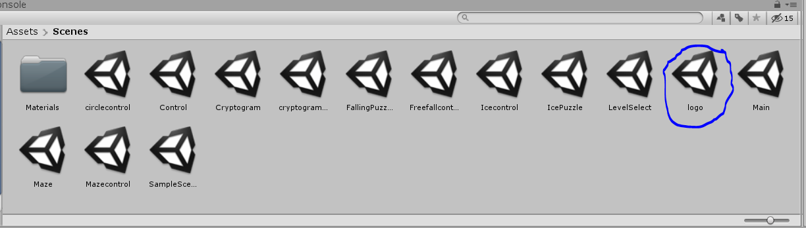

**3. Step by Step Instructions**

**3.1. Instructions**

*Once the game starts you will be introduced with a logo of our game and a start button. The main menu will include the following.*

1. *The main Logo screen and a start button*
2. *Afterward, a level select page to go to each level.*
3. *After each level, there will be a new screen to either go back to the main menu or start the game, choose accordingly.*

**3.2. Errors, Malfunctions, and Emergencies**

* *Check to make sure Mouse/Keyboard is plugged in.*
* *Check to make sure the correct Unity version (2019.2.0b3) is installed and in use.*
* *Exit the program and start the program again.*
* *Restart computer.*
* *Contact Developers if the problem persists.*

**4. Maze**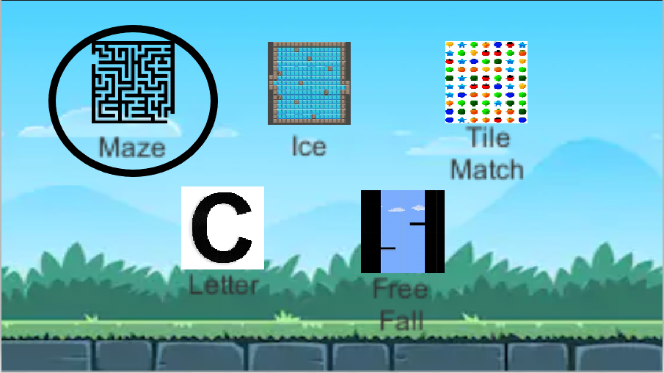

**4.1. Inputs and Outputs**

* **Once you are on the main level select menu click on Maze**
* **Once you click on Maze a new menu will pop up**

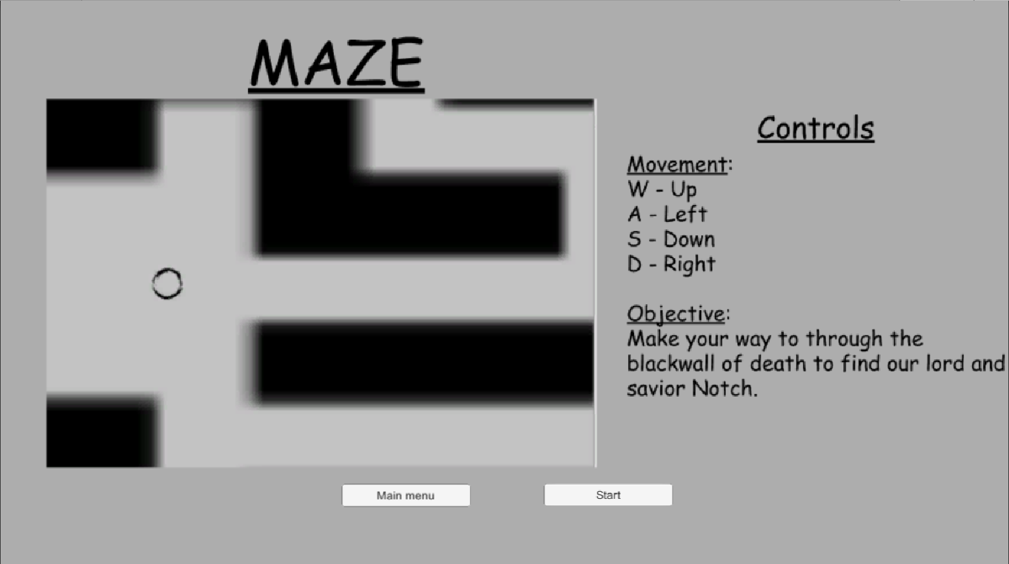

* **Click start to load the game or Main menu to return back to level select**

*Once you read the instruction and objective of the game you can proceed to play the game by clicking on the start button. If you want to go back to find a different game, click on the main menu. When the game loaded, you use the WASD key to control the player up, left, down and right motion. If the player touches the wall the player is prevented from moving in the direction of the wall they touch.*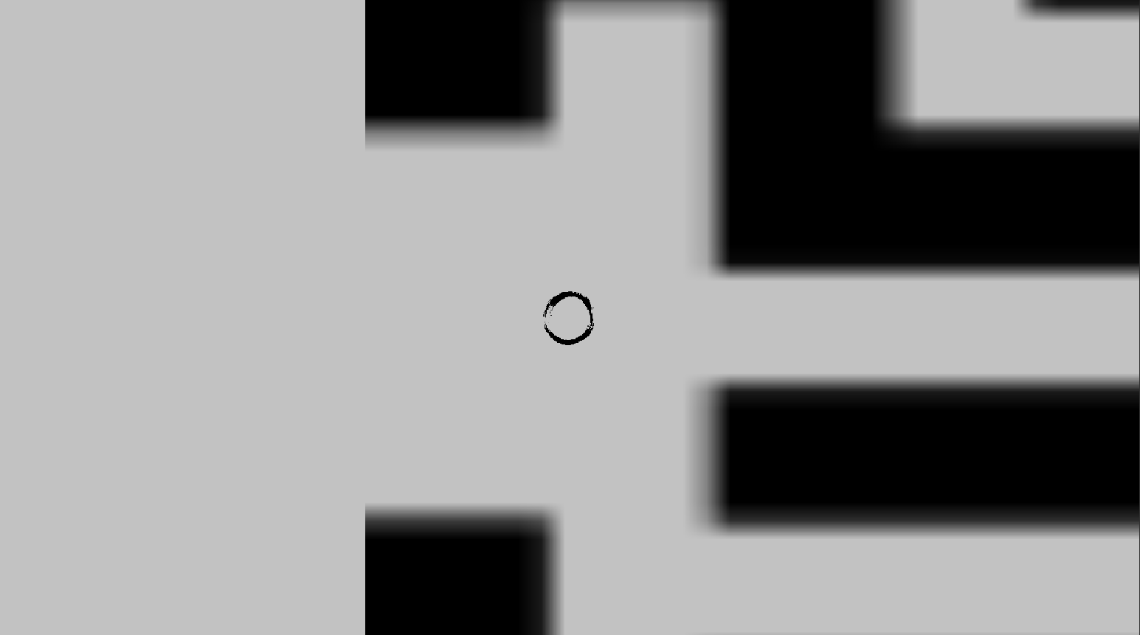

*Using this movement system navigate through the maze to the endpoint. Once you reach the end of the maze you will be teleported back to the level selector menu.*

**5. Ice Puzzle**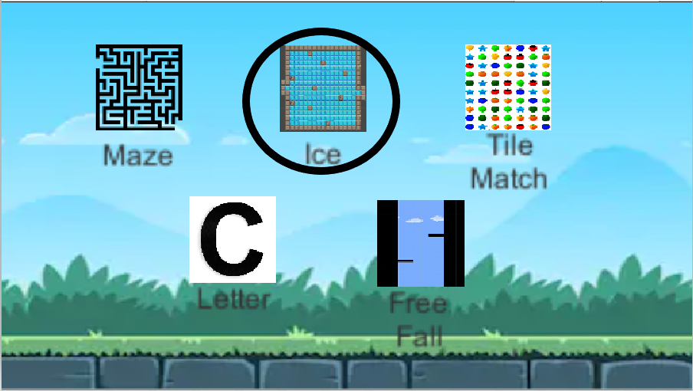

**5.1. Inputs and Outputs**

**Once you reach the main level select menu click the Ice button.**

**Once you click the ice game you will be introduced with a new menu.**

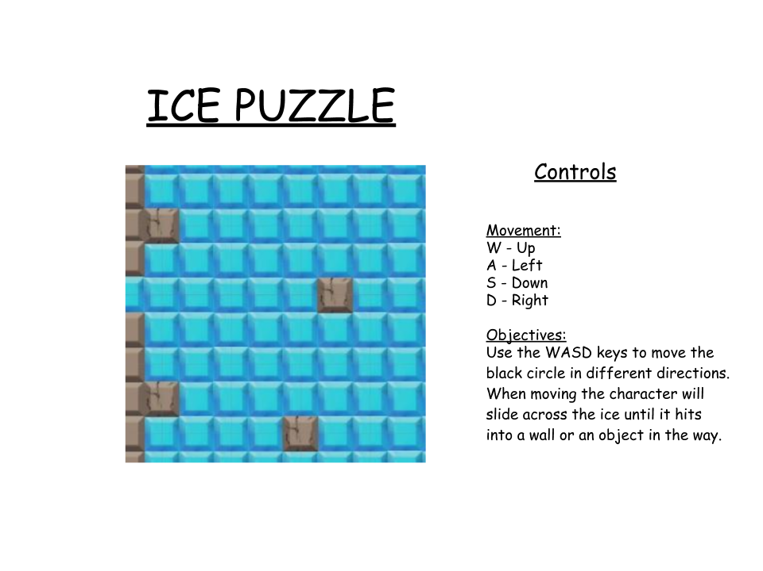

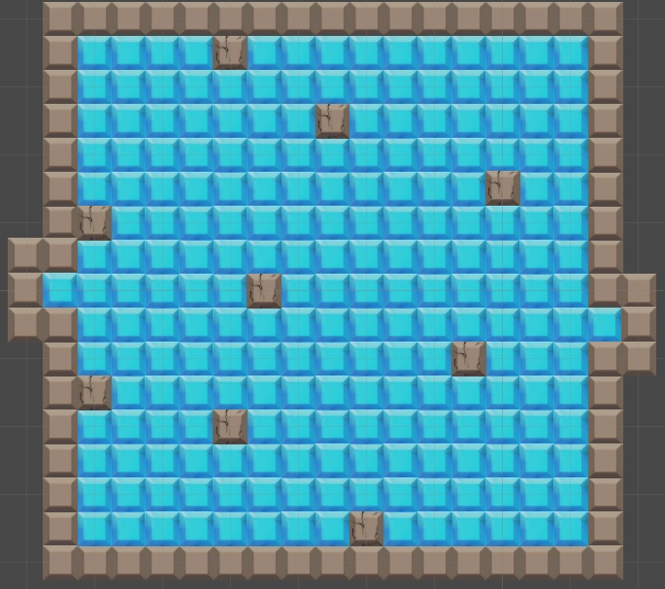

*This menu has the controls and objective of the game shown. If you decided not to play the game after seeing the controls and the objective then click on the main menu button. Once you feel like you know how to play the game and what to do in the game click the play button. When in the game use the WASD keys to move as stated in the controls and once you go in a direction you will not be able to change directions until hitting into a wall or a rock. Using this movement system navigate throughout the icy floor using the rocks and the walls to your advantage to make it to the small opening on the right side of the level.*

**6. Fruit Match**

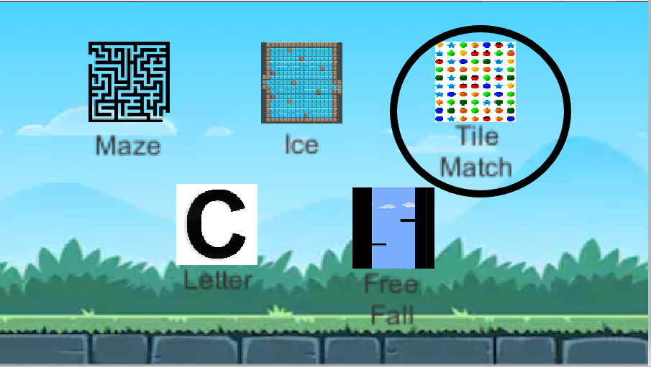

**6.1. Inputs and Outputs**

**Once you reach the main level select menu click the Tile Match.**

**Once you click the game you will be introduced with a new menu.**

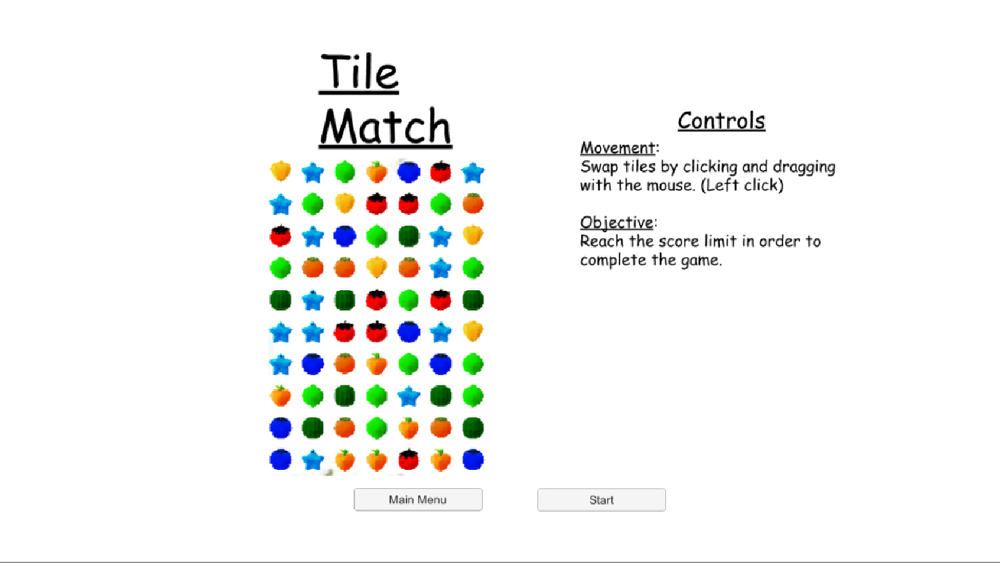

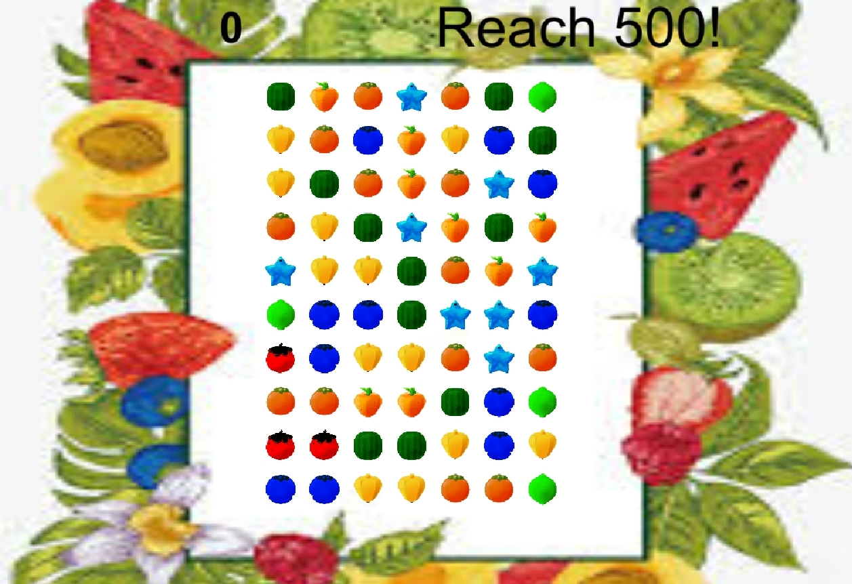

**Click Start and the game will load in.**

*Once the game starts, play away! To play the game use your mouse, there are no keyboard controls so the keyboard will not be necessary. To move each tile, click and hold each tile and drag them accordingly to match each tile to either making a match of three, four, five or however many you can get. Once a match has been made the score on the top left will go up by 20 for each tile match. So a match of three will give you 60 points. Whenever new tiles spawn, if they are luckily spawned in with having matching you will receive a point streak, so additional points! To win the game, reach a total of 500 points and you will be given a message that “You Win.”*

**7. Free Falling**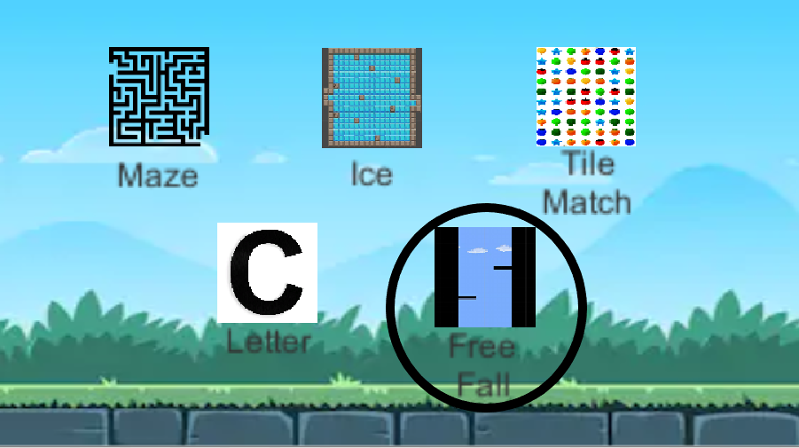

**7.1. Inputs and Outputs**

**Once you reach the main level select menu, click on Free Fall.**

**Once you enter the game you will be in**

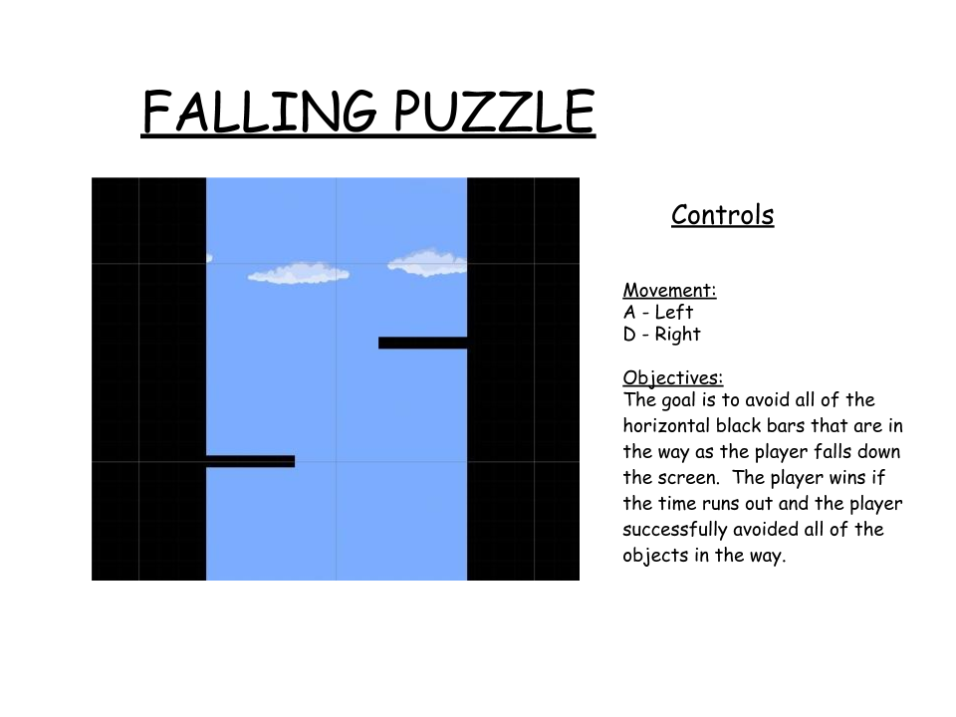

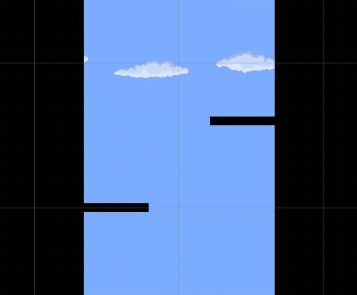

**Click “Start” and play the game!**

*When the game first starts out the character will start to fall at a slow pace, The pace will slowly pick up as if it is simulating gravity. The goal of the game is to dodge, as many obstacles as you can until the timer runs out. Once the timer runs out the game will end and you will return to the main menu. To control the character you have to use the left and right arrow keys( <- , ->) or the A and D keys to be able to move the character. Try to dodge as many obstacles as you can to avoid losing!*

**8. Cryptogram**

**8.1. Inputs and Outputs**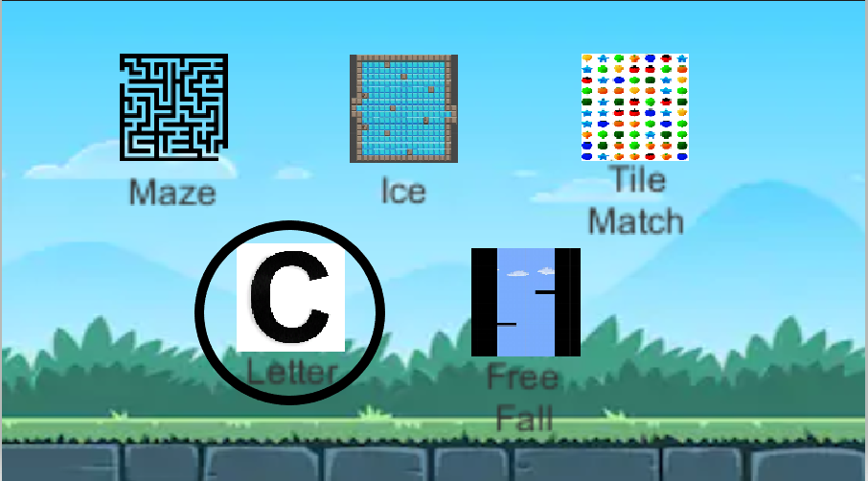

* **Once you are on the main level select menu click on Letter**
* **Once you click on Letter a new menu will pop up**
* **Click start to load the game or Main menu to return back to level select**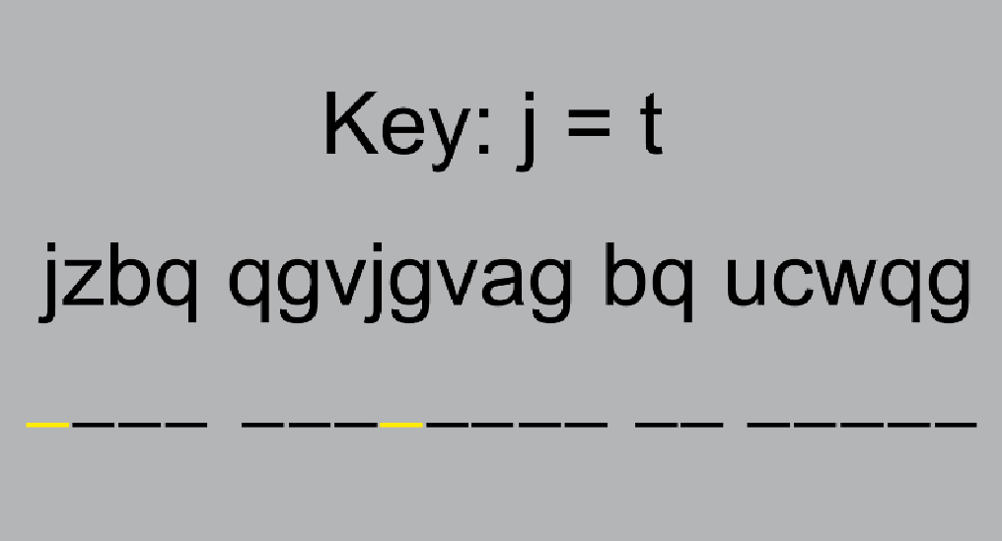

*Once you read the instruction and objective of the game you can proceed to play the game by clicking on the start button. If you want to go back to find a different game, click on the main menu. When the game loaded, you use the Left and Right Arrow keys to select different characters. Simply input any letter on the keyboard to change the selected letter. Use the key to figure out what the scrambled letters are actually saying. When you find the solution, you will be returned to the level select menu.*